Philip A. M c Ne ely, R.G. Director
Ph o n e : 602.506.670 1
Ema il: Ph ilMc Nee ly@m a il.mar icopa.gov

M aric opa .gov/ AQ
Clea nAirMakeM ore.c om
... O...,
tilt
a



May 12, 2017

Samantha K. Dravis Regulatory Reform Officer
Associ ate Administrator, Office of Policy
U.S. Environmental Protection Agency 1200 Penns ylva nia Avenue, N.W. Washington, DC 20460

Re: Comments on Executive Order 13777; Enforcing the Regulatory Reform Agenda, 82 Fed Reg. 17793 (4/13/17), Docket ID: EPA-HQ-OA-2017-0190

Dear Ms. D ravis:

The Maricopa County Air Quality Department (MCAQD) is responding to the U.S. Environmental Protection Agency's (EPA's) request for input on the President's February 24, 2017 Executive Order 13777: Enforcing the Regulatory Rejonn A genda. As the air pollution control agency for the fourth most populous county in the U.S., MCAQD permits and inspects thousands of pollution sources and maintains an extensive network of air pollution monitors.

Near-Road Minimum Monitoring Requirements

As part of the 2010 N02 National Ambient Air Quality Standard rulemaking (75 FR 6474), the EPA promulgated revisions to the requirements for minimum numbers of ambient N0 2 monitors which included new monitoring near major roads in larger urban areas, requirements to characterize N02 concentrations representative of wider spatial scales in larger urban areas, and monitors intended to characterize N0 2 exposur es of susceptible and vulnerable populations. Nationwide, over 130 new N0 2 monitors were to be installed in three (3) phases.

During Phase 1 and Phase 2, MCAQD installed two new near-road monitoring sites to supplement the existing three N0 2 monitors in the monitoring network.

EPA's evaluation of the Phase 1 and Phase 2 near-road site data (as of December 2015) concluded that near-road sites are indeed located at maximum concentration locations consistent with rule and guidance, confirmed that higher population areas have higher mobile source emissions than lesser populated areas, and that all existing near-road monitoring sites are "well below" the N0 2 NAAQS.

Subsequently and as supported by the evaluation of Phase 1 and Phase 2 data, in 2016 E PA promulgated a Revision to the Near-road N0 2 Minimum Monitoring Requirements (81 FR 96381) removing Phase 3 of the near-road network.

1001 North Central Avenue I Suite 125 I Phoenix, Arizona 85004

Samantha K. Dravis Da te: May 12, 2017

Page 2 of 2

MCAQD evaluates its monitoring network to determine that the data collected not only measures our performance against the National Ambient Air Quality Standards (NAAQS), but also serves a public benefit for research and to inform Maricopa County citizens of the local air qua lity.
Fortunately, the N02 data collected from the five N0 2 monitors in the network are consistently well below the N0 2 N AAQS. Under existing rule, the two near-road sites in MCAQD's network must be operated even if the data are of little or no public health benefit.

Thus, and for the rational that EPA removed Phase 3 from the near-road monitoring requirements, MCAQD requests that EPA review the 2010 N0 2 National Ambient Air Quality Standard rulemaking, reflect on the available near-road data, and work with stakeholders to assess whether the minimum N0 2 monitoring requirements are resulting in public health benefit in light of what has been observed to date and the continued cost to operate these additional monitoring sites.

Regards,
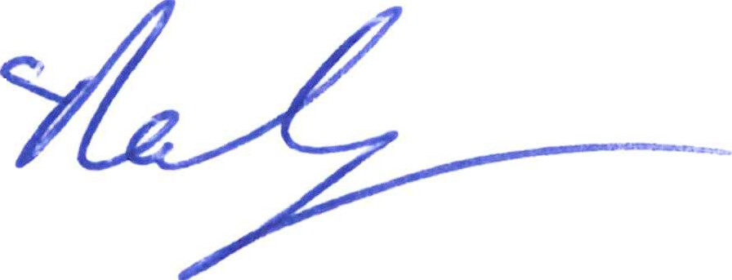
0 /:/ ;f#
Phili eely, R.G . Director

1001 North Central Avenue I Suite 125 I Phoenix , Arizona 85004

